6BCA - BCA672A - CLOUD COMPUTING
CAT 2

Keep the pictures whatever you are having for Task 1.

1. Protect the virtual machine from accidental termination.

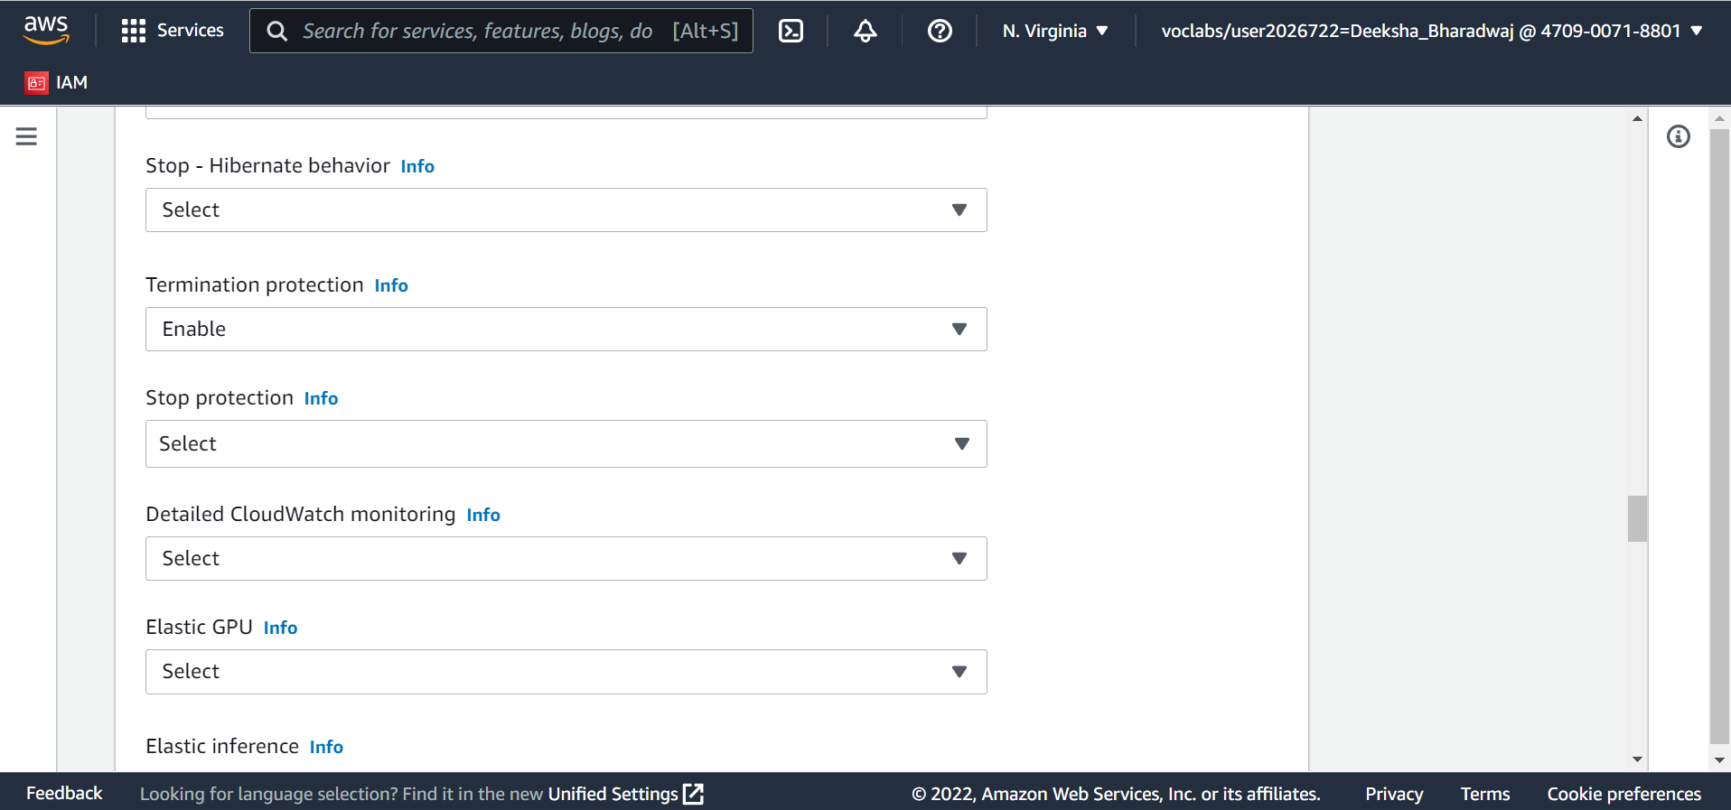

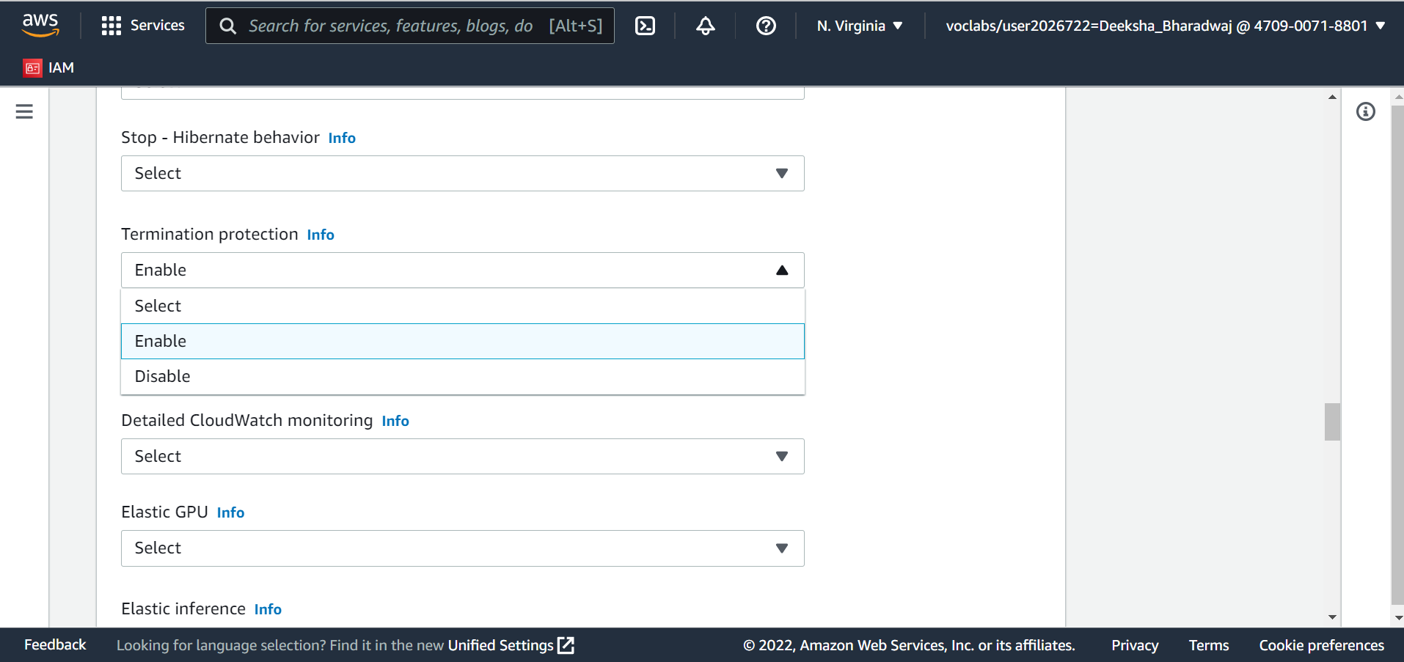

2. Summarize the configuration of your virtual machine.
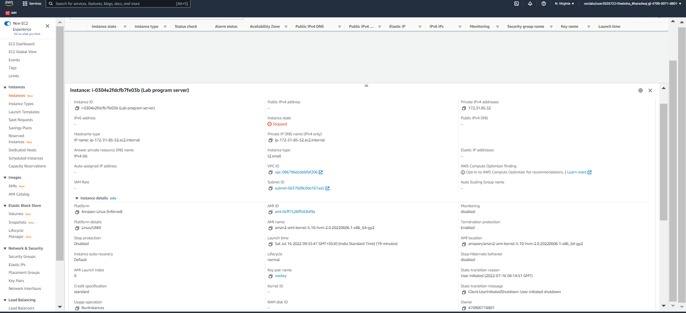

3. Present the snapshot of your EC2 instance.

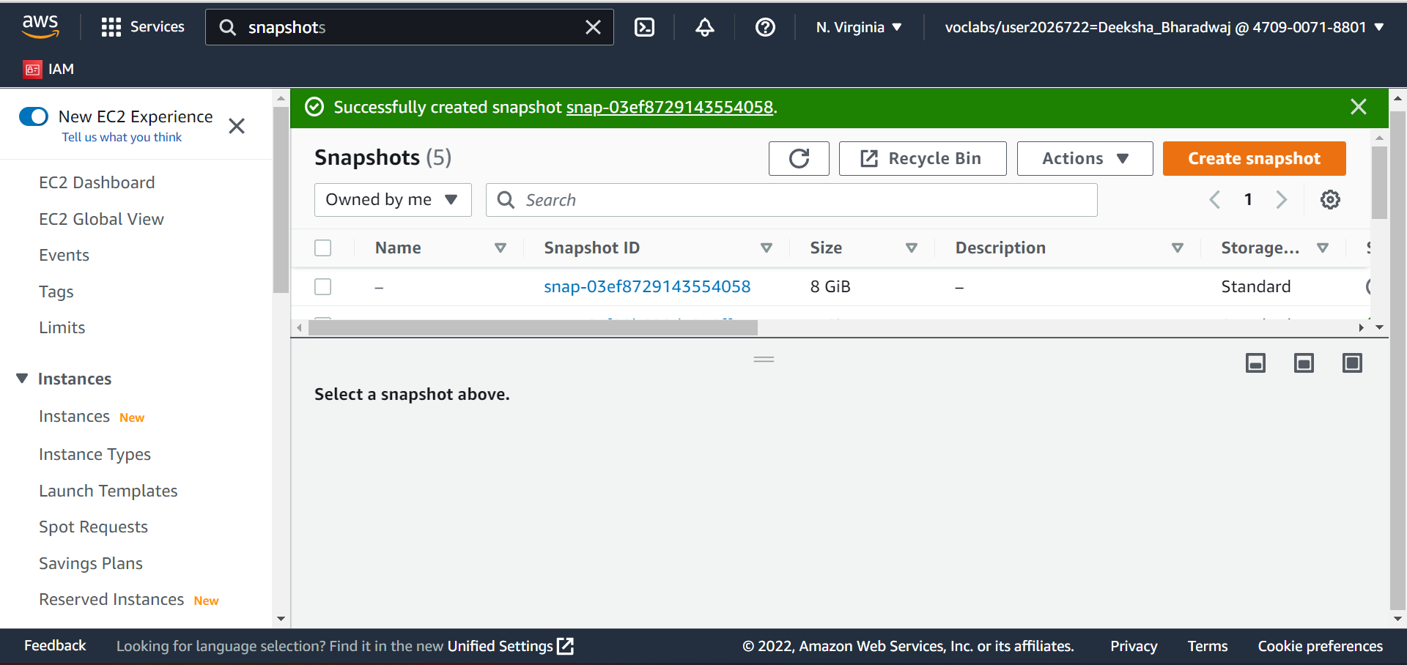

4. Change the instance type
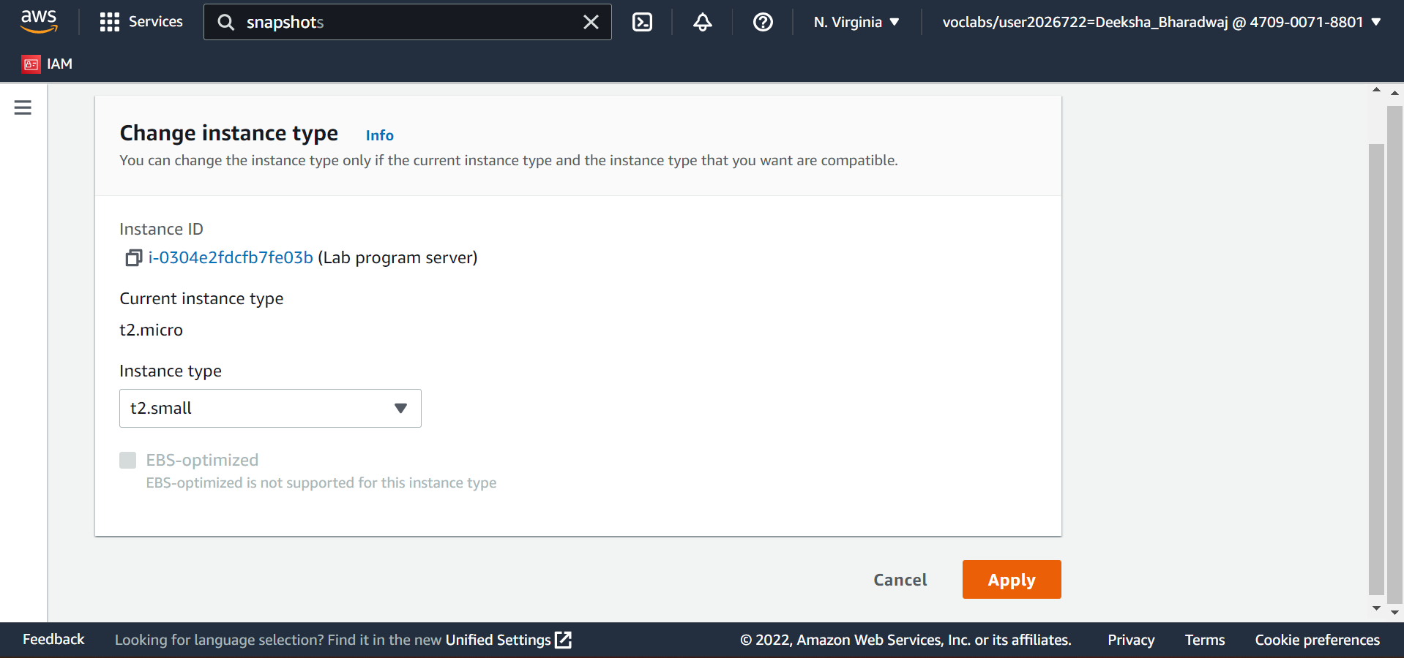

5. Change the EBS volume size
